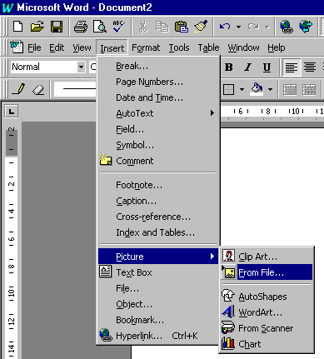
Step 1
Have a new blank Word document.
I usually have my page setup as landscape as this caters for fold out covers.
But if they're just one sided, portrait is fine.

Step 2
From the Insert menu choose, picture - from file.

Step 3
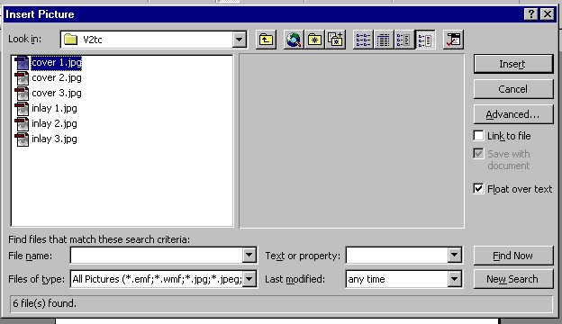
Locate the file you want to insert eg ‘cover1.jpg’
Float over text, means you can drag it anywhere on the page. If not ticked then it treats the picture as if it is a piece of text.

Step 4
Press insert
The picture will appear on your screen – it probably wont be the correct size.

Step 5
Click on the picture (once) to select it.
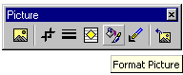
A toolbar should appear that looks something like this: (if not it can be found in View – Toolbars – Picture

[My toolbar has less buttons than normal as I deleted the buttons that I don’t use.]

Click on the one that says Format Picture and the following window appears (next page):

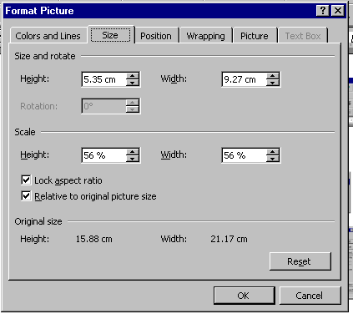
This allows you to set the height and width of the image.
You actually only have to change one value as the other changes when you press OK, if the Lock aspect ratio is selected.

The front cover of a CD (to my knowledge) is 12.11 cm in height and 12.05 in width (sorry, but I don’t work with inches).

The rear inlay is usually 11.73 high and 14.94 in width.
(For this one the width is much more important than the height should you get a scan from someone that isn’t in correct proportions.

Then it’s just a matter of positioning it where you want on the paper and printing.
Printing sizes added by randy@zeppelinart.com

(height x width) | US (inches) | Metric (cm)
Jewel Case Front | 4.75 x 4.75 | 12.07 x 12.07
Jewel Case Back (and Front Quad) | 4.63 x 5.91 | 11.76 x 15.01
Cardboard slipcase (no spine) | 4.75 x 4.75 | 12.07 x 12.07
Gatefold Front/Back | 4.75 x 9.50 | 12.07 x 24.14
Trifold | 4.75 x 14.25 | 12.07 x 36.20
VHS Case | 7.50 x 10.10 | 19.05 x 25.65
DVD Case | 7.10 x 10.80 | 18.03 x 27.43

